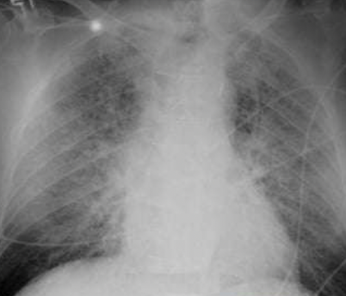  55 year old male with history of hypertension presents with shortness of breath for 6 hours.  - What are the findings?  - What is the diagnosis? | Ix  - AP view, underexposed. Cephalization, perihilar & diffuse intestinal opacities, cardiomegaly, no effusion, cephalization, Kerley B-line. Leads visible  - AdHF sec HHD ddx: Atypical pneumonias: COVID/PJP if immune suppressed  - Do ECHO for EF, Structure, Valves. ECG r.o arrythmia  - BNP/NT-proBNP can help exclude HF; levels ↑ w/ age, renal dysfxn, AF; ↓ w/ obesity  - Evidence of ↓ organ perfusion: ↑ Cr, ↓ Na, abnl LFTs, ↑ lactate  - Echo: ↓ EF & ↑ chamber size → systolic dysfxn; hypertrophy  Rx  - 02 therapy viz NP/ HFNC, Position (sitting up & legs dangling → ↓ preload) target 90%  - IV furosemide 40mg if treatment naïve, 2.5x oral dose if was on treatment (DOSE Trial)  - Iron Carbomaltose 1gm stat repeat after a weak then test hb in 4wk; if ferritin <100 or 100–300 & TSAT<20%. Alternative Fe-Sucrose 200mg/wk repeat – 5 times. Monitor transfusion reactions.  - Start GDMT as early without contraindication to maximum dose tolerable  - T. dapagliflozin 10mg od (egfr must be >25) (DAPA-HF)  - T. carvedilol 6.25 mg bd US Carvedilol Trial, also Bisoprolol 5mg od (CIBIS-II), Metoprolol Succinate 25mg bd (MERIT-HF)  - T. spironolactone 6.25-25mg od (RALES Trial; NYHA III/IV) or Eplerenone (EMPHASIS Trial)
Pt presented with PND, orthopnea requiring 4 pillows, shortness of breath while climbing a flight or stays currently only sits in the living room.  - What is your diagnosis  - ⁠what are your expected findings on examination  - ⁠classify/stage your diagnosis  - ⁠treatment including dose, route | Ix  - Congestion: (“dry” vs. “wet”): ↑ JVP >9 ⊕ hepatojugular reflux: ≥3 cm for RA. Rales, dullness at base 2° pleural effus. (often absent in chronic HF due to lymphaticcompensation) ± hepatomegaly, ascites and jaundice, peripheral edema  - Perfusion: (“warm” vs. “cold”) narrow pulse pressure (<25% of SBP), pulsus alternans, cool & pale extremities, ↓ UOP, muscle atrophy  - ± Other: Cheyne-Stokes resp., abnl PMI (diffuse, sustained or lifting depending on cause of HF),  - S4 (diast. dysfxn), murmur (valvular dis., ↑ MV annulus)  Rx  - Tailored Rx w/ PAC (qv); goals of MAP >60  - “LNOP” for congestion:  - IV loop diuretics (2–2.5× usual total PO dose) ± thiazides or acetazolamide; no clear Δ between gtt vs. IVB q12h; oral bioavailability ~50% for Lasix (so IV 2× as potent as PO).  - Nitrates, 5mcg/min infusion esp. if HTN (↓ preload).  - Oxygen target >90% NIV  - Position (sit up & legs dangling → ↓ preload)  - Home meds: prefer to continue, except:  - RASi: hold/↓ dose if HoTN, SBP<90; Δ to hydral/nitrates w/ AKI  - βB: hold if hypoperfusion or HoTN
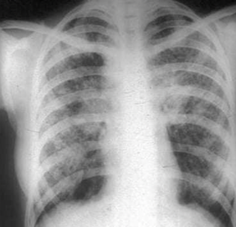  A 35 year old male presents with progressive shortness of breath for last 6 month. He also has dry cough and joint pains.  - What are the findings in this chest X Ray?  - What is the diagnosis?  - List two differentials.  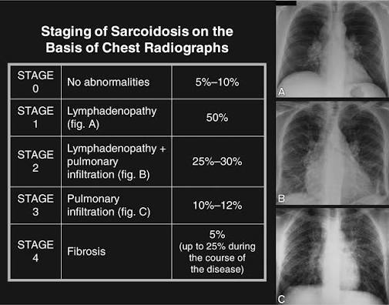 | Ix  - PA view, underexposure, Bilateral hilar adenopathy, infiltrates heterogenous  - DDx: Sarcoidosis (stage 2: perihilar LN w/ infiltrates), Berylliosis, Lymphoma, Granulomatous disease (TB, NTM), Metastatic cancer, Atypical Pneumonias e.g., mycoplasma, RA with UIP  - Do Gene Expert, AFB, Culture & DST, ACE levels, ESR, CRP, Bronchoalveolar Lavage, FBP, smear, LN bx → noncaseating granulomas + multinucleated giant cells  Rx  - if sx or extra thoracic organ dysfxn (e.g., prednisone 20–40 mg/d), taper over 6-12 month. Can add MTX 15-10mg/week as steroid sparing therapy, hydroxychloroquine for skin disease, AZA, MMF  - Methotrexate: Inhibits folate reduction by DHFR to FH4.  - partially selective rapidly dividing normal cells  - intestinal: GI upset, NV gastritis, colitis  - bone marrow suppression: pancytopenia’s, alopecia, hepatotoxicity  - give with folic acid daily 5-10mg od  - toxic effects terminated by leucovorin, a fully reduced folate coenzyme replenishing
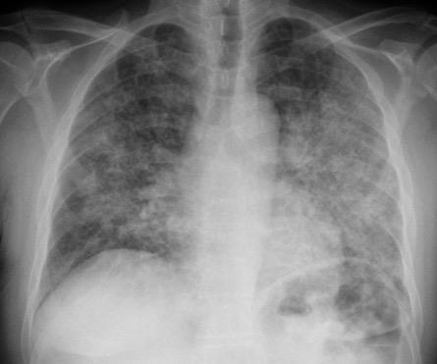  Pt with foul smelling productive sputum; drenching night sweats, fever.Given a chest xray  - Interpret the findings in CXR  - ⁠what is the diagnosis  - ⁠possible causative organism | Ix  - PA view good exposure, no rotation. Trachea not deviated, no bone lesion, normal aortic knuckle, no cardiomegaly, free costophrenic space, with hilar LN and heterogenous bilateral opacities marked on the middle lung zone severe on the lt lung  - Dx: PCP, DDx PTB  - Other: Sputum Gram stain/cx: reliable if high quality (ie, sputum not saliva; <10 squam cells/lpf).  - If bacterial PNA should be purulent (>25 PMN/lpf). Yield ↓ >10 h after abx  - Procalcitonin: ↑ in acute bacterial (not viral) PNA. Consider stopping abx if levels <0.25  Rx  - TMP-SMX 1920mg tds 21 days & T prednisolone 40mg bd5/7; 40mg od 5/7, 20mg od 11 days  - Start ARTs immediately within 7 days
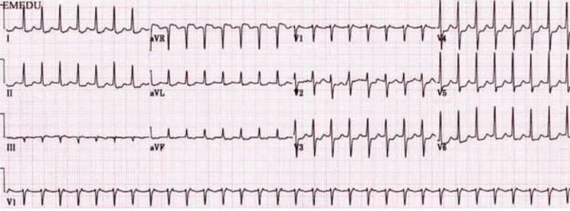  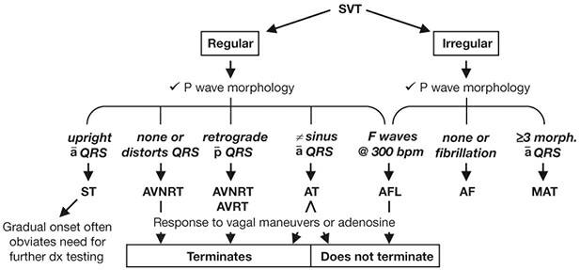 | Ix  - Regular rythm, no p waves; buried in or deforming terminal QRS, eg, pseudo-RSR′ in V1) →typical AVNRT, NPJT, fine AF.  - Rate- 187. Normal axis. Narrow (normal QRS) hence confirms this to be SVT as its regular.  - If Irregular → AF, AFL w/ variable block, or MAT  - Patient has hemodynamic instability asses: Altered, Ischemia pain, Shock, Hypotension, AHF: AISHA  - Order etiology: TSH, Electrolytes etc  Rx  - Response to vagal stim or adenosine 6mg (caution in AVRT*), stat, subsequent dose within 1min as it has fast acted and short t1/2: 12mg, 12mg: Slowing of HR seen with ST, AF, AFL, AT  - If failed/stabilizes and EF is normal CCB, or IV amiodarone 150mg stat then c/w infusion 1050mg/24hrs max being 1200mg/day then oral if can tolerate 200mg od.  - Catheter ablation: high overall success rate
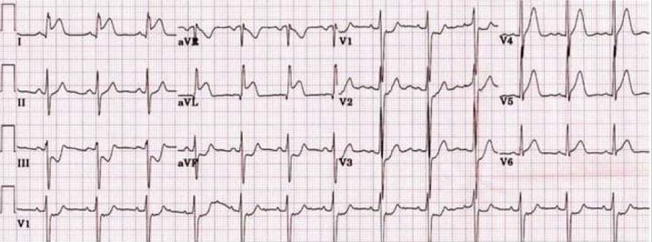  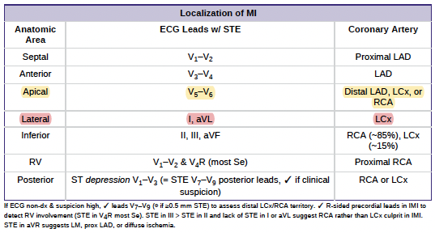  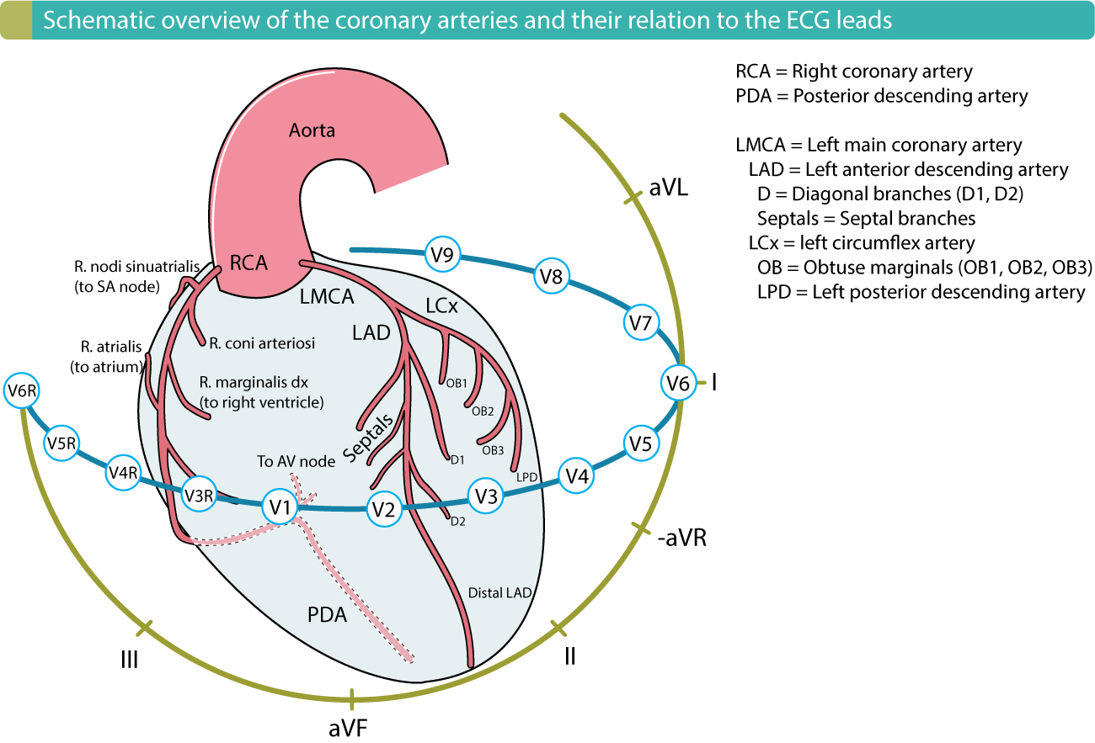  A man came with a crushing chest pain that is radiating to the left shoulder  With and ecg provided  - Describe the abnormalities on the ECG  - What is the likely diagnosis (with territory dominance)?  - What will be the immediate management? | Ix  - Irregular sinus rhythm with left axis deviation. Rate 78bpm, with normal PR progression, ST elevation on limb I & aVL and hyperacute T waves in lateral precodial leads: V4-5 with reciprocal changes in I, aVR, V1-V3  - Ddx: STEMI. ECG w/in 10 min of presentation, with any Δ in sx & at 90mins, 6–12 h  - ✓ Tn (pref. over CK-MB) at presentation & 3–6 h if cTn, 1–2 h later if hsTN  Rx  - IV morphine 4 mg @ 5min max 10mg + SL Nitrates 0.4mg q5min ×3 repeat  - β-Blockers eg, metop 25–50 mg PO q6h titrate to HR 50–60  - Caution if preload-sensitive (eg, HoTN, AS, sx RV infarct); contraindic. If marked brady/tachy or recent PDE5i use.  - Oxygen Use if needed to keep SaO2 >90; Hb goal of ≥8 g/dL  - DAPT  - Aspirin: 162–325 mg stat, then 75 mg od 1yr of DAPT  - Ticagrelor (preferred over clopi) 180 mg × 1 → 90 mg bid  - Clopidogrel (300–600 mg stat) → 75 mg  - UFH: 60 U/kg IVB (max 4000 U as a push during PCI) then 12U/kg/h (max 1000 U/h initially) × 48 h or until end of PCI OR Enoxaparin 1 mg/kg SC bid (od if CrCl <30) × 2–8d if not going for immediate PCI  - In PCI-capable hospital, goal should be primary PCI w/in 90 min of 1st medical contact  - In non–PCI-capable hospital, consider transfer to PCI-capable hospital (if PCI w/in 120 min of 1st medical contact), otherwise fibrinolytic therapy w/in 30 min of hospital presentation  - IV Alteplase <60 kg: 30 mg; 60–69 kg: 35 mg; 70–79 kg: 40 mg; 80–89 kg: 45 mg; ≥90 kg: 50 mg. OR  - IV Tenecteplase 15 mg bolus → ≥67 kg: 50 mg/30min + 35 mg/60min; <67 kg: 0.75 mg/kg (max 50)/30min + 0.5 mg/kg (max 35)/60min.  - If was NSTEMI ACS:  - Immediate/urgent coronary angiography (w/in 2 h) if refractory/recurrent angina, hemodynamic or electrical instability, s/s HF or cardiogenic shock  - Early (w/in 24 h) if: steeply rising Tn, ongoing dynamic ST Δ, GRACE risk score >140  - Delayed (ie, w/in 48–72 h) acceptable if: GRACE 109–140, stable or ↓ Tn, sx resolved  - PCI of all significant non-culprit lesions (either at time of procedure or later during hosp.) ↓ CV death & recurrent MI
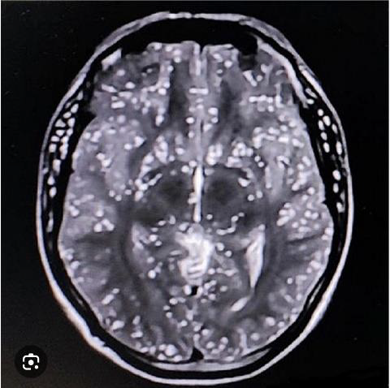  16y/o female from urban mountainous region. Presenting with altered mental status, sided weakness. MRI of the brain showed…  - Interpret the findings in the MRI  - ⁠What is the diagnosis  - ⁠what other test would you perform to confirm the diagnosis  - d. ⁠how to manage/treatment | Ix  - In axial T2-weighted brain MRI that demonstrates a classic "starry sky" appearance: brain parenchyma is diffusely and symmetrically studded with innumerable small, round, hyperintense (bright) cystic lesions.  - Ddx: Disseminated Neurocysticercosis, Miliary Tuberculomas, Fungal Microabscesses i.e cryptococcomas or Toxoplasmosis, Diffuse Cerebral Metastases  Rx  - Albendazole 15mg /kg and/or Praziquentel 50mg/kg in tid 14d for 2 weeks if in parahcymal and 4weeks if subarachnoid. give both if more than 3 lesions  - Also add steroids: dexamethasone 6mg/d for 28days  - If with seizures levetiracetam
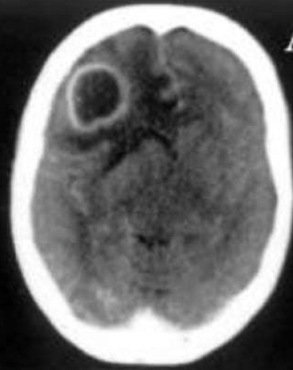  Based on the presentation of a 30-year-old IV drug abuser with fever, focal seizures, altered mentation, and left-sided weakness, here are four possible differential diagnoses:  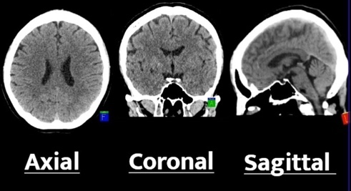 | Ix  - Contrasted CT brain, axial view at high convexity level with a single ring enhancing lesion in the right frontal cortex. w/ surrounding vasogenic edema and mass effect (anterior falci is slight to the left)  - Further order Toxoplasmosis IgG &M  - Ddx: Cerebral Abscess, Tuberculoma, Toxoplasmosis, Primary CNS lymphoma; Least (cryptoccomas, PML)  - Do ECHO r.o infective endocarditis septic emboli.  - HIV Bioline, if +ve CD4, VL.  - Lumber Puncture: cytology looking for PMN and Lymphocytes, Chemistry Protein if >0.4. RBG CSF: Ser. LDH, microbiology AFB, GeneXpert, CrAg  - transsphenoidal biopsy  - Common CT Axial Levels  - Foramen Magnum / Posterior Fossa: Shows the brainstem, cerebellum, and lower fourth ventricle.  - Sella Turcica / Basal Cisterns: Displays the temporal lobes, pons, and suprasellar cistern.  - Level of the Basal Ganglia: Shows the thalamus, internal capsule, and frontal/occipital horns of the lateral ventricles  - High Convexity: Shows the high cerebral cortex and superior sagittal sinus just beneath skull
Dx | Site | Number | Size | Enhance? | Test | Treatment
Toxoplasmosis | Basal ganglia, thalamus, subcortical WM, cerebellum | Multiple (80%) | 2–3 cm | Ring (+ eccentric nodule) | Serum IgG, CSF PCR | Pyrimethamine + Sulfadiazine + Leucovorin; ART
PCNSL | Basal ganglia, corpus callosum | Solitary or multiple | >4 cm | Ring or homogenous | CSF EBV PCR, biopsy | High-dose MTX + ART
PML | Subcortical WM (U-fibers), cerebellar peduncles | Multiple asymmetric | Confluent | None (or faint) | CSF JC virus PCR | ART (only therapy)
Cryptococcoma | Basal ganglia, cerebellum | Solitary/few | 1–4 cm | Ring/nodular | CSF CrAg, biopsy | Amphotericin B + Flucytosine → Fluconazole; delay ART
CNS TB | Basal cisterns, basal ganglia, parenchyma | Diffuse or single/multiple | 0.5–4 cm | Meningeal (basilar); ring (caseating) | CSF PCR/ADA, chest imaging | RHZE + steroids; ART after 2–8 weeks
Brain Abscess | Frontal/parietal lobes (hematogenous) | Solitary or multiple | 1–5 cm | Smooth ring | DWI MRI, blood cultures, aspiration | Vancomycin + Ceftriaxone + Metronidazole; surgery if >2.5 cm
HIV Vasculopathy | Small/medium arteries (ACA, MCA, PCA) | Multiple aneurysms/infarcts | Variable | Vessel wall enhancement | MRA/CTA, vessel wall MRI | ART, Aspirin

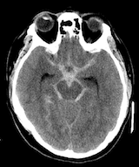  A 55-year-old hypertensive male presents with sudden onset of headache and irritability.  - What is the diagnosis?  - How will you manage?  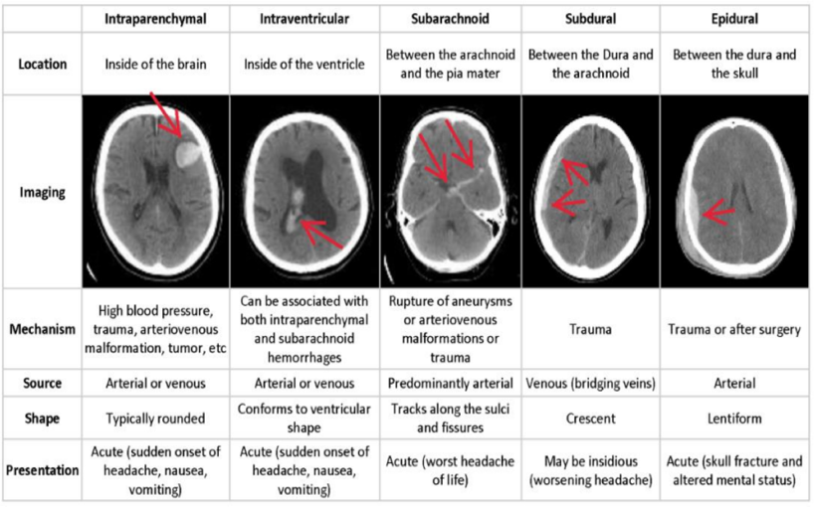 | Ix  - Axial view non contrasted CT Brain, with hyperintensity that tracks along the sulci & fissures ~ star sign.  - What else to order? Angio (CT-A or conventional) if suspicious for vascular source  - Coags (PT, PTT, INR)  Rx  - As for any Intercranial haemorrhage due HTN, 1st BP control w/ art line, IV nicardipine 5mg/hr or labetalol 10-20mg over 2mins then 2-8mg/min as infusion; max 300mg/day titrated to SBP goal <140 for 1st 24 h, then <160  - As this is SAH: nimodipine 60mg qid for 21 specificially to ↓ risk of vasospasm that causes delayed cerebral ischemia.  - Surg evac: EDH; SDH if >1 cm or rapid ↑, Rx-resistant epilepsy  - Venous sinus thrombosis: start anticoagulation prophylactic dose leviceteram 500mg od-7d if high risk features, manage ↑ ICP and seizures as needed  - Reverse coagulopathy, INR <1.4. Plt >100k, no need for plt tfn if on antiplt Rx (? if ↑ ICH), DDAVP if uremic. 2–3 mo later can restart antiplt mono Rx  - Keep on antihypertensives
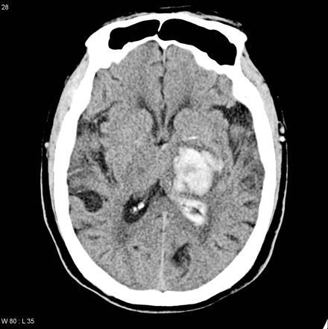  A man came with a sudden onset of right sided weakness, his blood pressure was 209/115 not on medication with a CT provided  - Can u describe the finding on the Ct scan?  - What is the most likely diagnosis?  - How will u treat the pt.? | Ix.  - Axial view ct brain ventricle levels, hyperdense lesion on left hemisphere, irregular bordar with extension to ventricles, no midline shift or significant surrounding edema  - STAT CT brain, angio (CT-A or conventional) if suspicious for vascular source. Coags (PT, PTT, INR)  - Also: K, BUN, Cr, Ca, glc, Hct, U/A, lipids, TSH, urinary albumin:creatinine (if ↑ Cr, DM, peripheral edema), renin/aldo, ECG (for LVH), CXR, TTE (eval for valve abnl, LVH)  Rx  - Manage as above
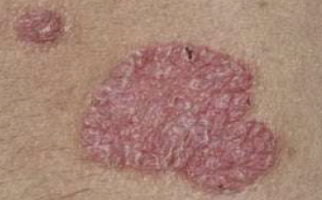  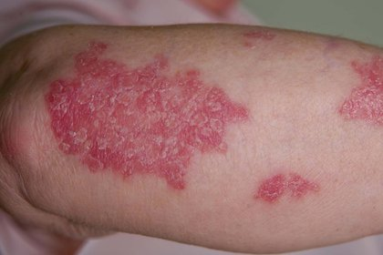 | Ix  - 2 lesions consisting of firm, flat-topped, shiny, polygonal, 1–3 mm plaques with a red to violet color.  - Tracery of thin white lines can be seen on  - surface of lesions, known as Wickham’s striae  - Ddx: Psoriasis, Tinea Corporis  - Also do skin biopsy. 3mm punch biopsy  Rx  - potent steroids clobetasol propionate ointment 0.05% bd till remission OR intralesional triamcinolone  - if widespread prednisolone 40mg od tapered down OR second line; ciclosporin, azathioprine, PUVA or MTX 15mg/weekly, hydroxychloquine.  - Comparison to plaques psoriasis  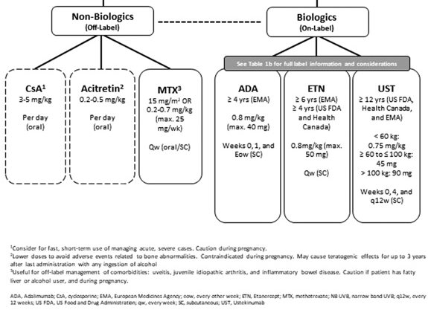
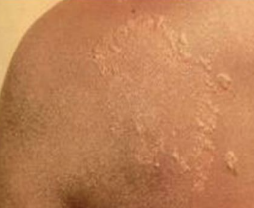  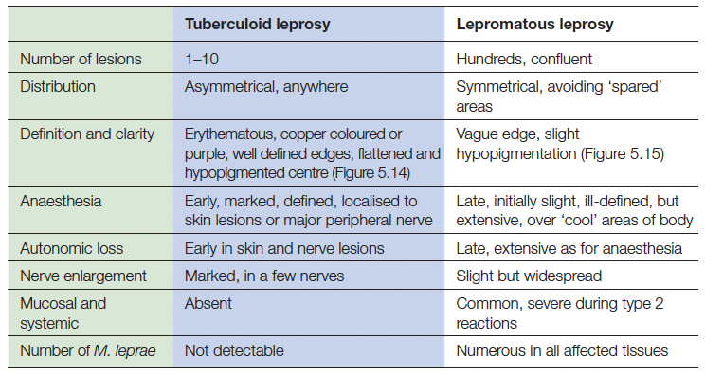  (most literatures lesions <5) | Ix  - ? circular or oval scaly patch with a raised, active border and central clearing  - DDx: Granuloma Annulare, T. Corporis, Lepromatous Leprosy.  - Do biopsy. ADA.  Rx  - Tuberculoid leprosy (paucibacillary, low bacterial load)  - rifampicin 600mg once /month and dapsone 100mg od for 6 months.  - Lepromatous leprosy (multibacillary)  - rifampicin, dapsone 100mg od, and clofazimine 300mg once/month then 50mg od rest of days for 12 months  If this was really Tinea Corporis:  - common organism: Trichophyton rubrum and Microsporum canis. The source of infection is an active lesion on an animal or human.  - Localized disease: topical terbinafine or azole.  - Widespread disease: 1st line: Oral terbinafine or itraconazole, 2nd line: Griseofulvin 1 g/day for 4 weeks.
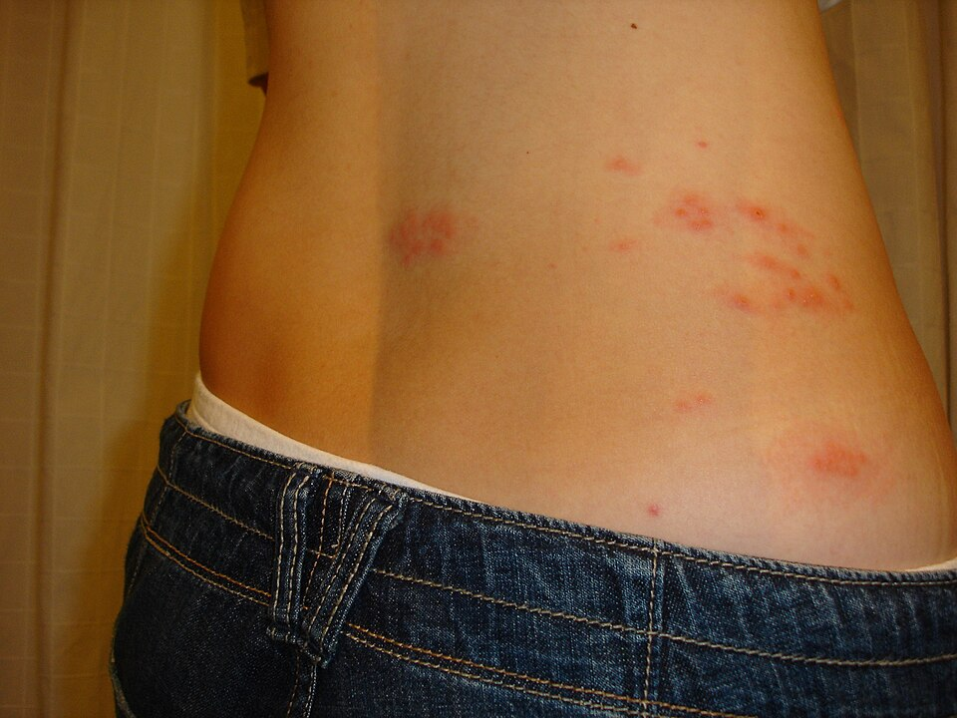 | Ix  - Asymmetrical dermatomal T10-L2 distributed multiples papules and vesicles, coalescing, with erythematous base not crossing the midline  - Ddx: Varicella Zoster, can disseminate: Ramsey Hunter syndrome (Oticus + VII palsy) meningoencephalitis?  - Post-herpetic neuralgia: neuropathic pain lasting >90 d after dx  - vesicles on nose indicate involvement of nasociliary nerve (Hutchinson sign).  - Ophthalmic zoster: ocular involvement (V1 of CN V) requires urgent ophtho eval: complications include uveitis, keratitis, conjunctivitis, conjunctival oedema, ocular muscle palsies, proptosis, scleritis  Rx  - Uncomplicated: topical & oral acyclovir 800mg qid, valacyclovir, or famciclovir × 7 d; initiate w/in 72 h. minimal benefit after crusting  - Calamine/Antihistamines for itching + T. pregabaline75mg/T. amitryptine 25mg od  - Disseminated/immunosuppress.: IV acyclovir  - Superimposed bacterial cellulitis is common; if suspected, treat with appropriate antibiotics  - Prevention: Shingrix (2 doses) for all Pts >50 or immunosupp. adult ≥19 yrs
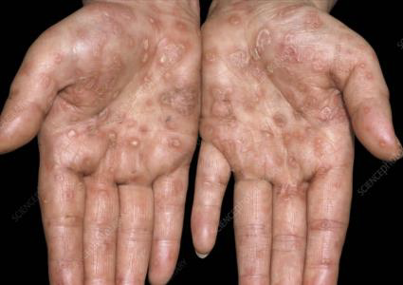  24y/o with a chancre at his penile shaft and later presented with multiple lesions on his hands  - Describe the skin lesions  - What is the diagnosis  - ⁠what are your differentials  - ⁠what is the confirmatory investigation  - e. ⁠what is the initial treatment | Ix  - 1°: chancre = firm, indurated, clean base.  - 2°: fever, rash palms/soles, uveitis, condylomata lata.  - 3°: aortitis, gumma, palsies 7/8, tabes dorsalis, meningi  - Latent = asx; early latent <1 yr; late >1 yr/unknown  - 1st step is treponemal test: IgG to T. pallidum. Often ⊕ for life.  - 2nd step: confirm w/ non-treponemal test (VDRL/RPR titer). Should ↓ 4-fold w/ Rx.  - Neurosyphilis: LP not needed if only ocular or otic sx. CSF VDRL may be ⊖.  Rx  - Syphilis: 1°/2°/early latent: PCN G benzathine 2.4 mil U IM × 1; 3°/late latent: PCN G 2.4 mil U IM × 3; Neuro: IV PCN G 4 mil U q4h 10–14 d
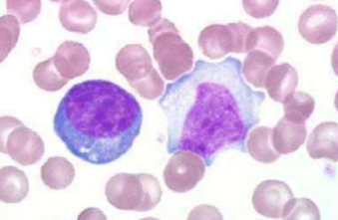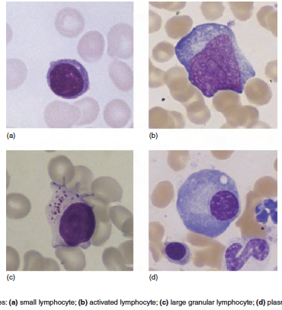  An 18-year-old girl with fever, sore throat, and cervical lymphadenopathy, the peripheral blood film most likely shows? | Ix  - This is thin smear as thick RBCs shapes are usually deformed.  RBCs  - The inter RBC distance is normal and rbc are normal? Not likely anemia  - Normal size and shape (so neither aniso-(shape) nor poikilo(size) shape.  - Central pallor is also normal. if >1/3 of the RBC diameter its hypochromic => IDA. Also mature have no nucleus  WBC  - Activated (reactive) lymphocyte – large (~neutrophil size), abundant cytoplasm, less condensed chromatin (viral infections).  - No Smudge cells – ruptured small lymphocytes, nuclear smear without cytoplasm/membrane (↑ in chronic lymphoid leukemia  - Also order monospot test (heterophile antibody test), EBV serology – EBV VCA IgM (acute infection), VCA IgG (past infection), EBNA IgG (past).  - Full blood count with differential – to confirm lymphocytosis and atypical lymphocytes. CMV serology – if Monospot is negative (CMV can cause similar picture).  - DDx: CMV mononucleosis, Acute HIV seroconversion
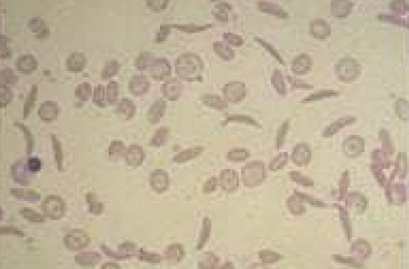  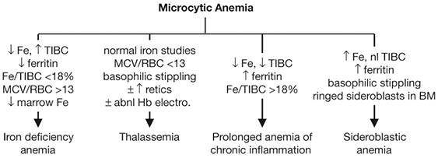 | Ix  RBC  - Few sparse RBC in the field ->anemia, sickled RBCs, targetoid cells, tear drop cells, variation in size & shape = anisopoikolocytosis.  - DDx:  - Hemoglobinopathies likely SCA, r/o beta thalassemia and hereditary spherocytosis  - Hemolytic anemias?  - Do also HLPC, HB-electrophoresis, FBP, Ferritin, TSAT, Fe levels. LDH, BilD+T, Reticulocyte Count.  - Vaso-occlusive episodes: stroke, MI, acute chest syndrome (vide infra), VTE, renal papillary necrosis, avascular necrosis, dactylitis, priapism, retinopathy  - Functional hyposplenism → bacteremia, meningitis, PNA, etc. from encapsulated organisms. Vaccinate against Pneumo., Meningo., H flu; also, HBV  Rx  - Disease-modifying: hydroxyurea (↑ HbF)  - Gene therapy: Exa-Cel  - 1° indications for tfn: acute chest syndrome, CVA, sx anemia w/ Hgb 2 g/dL below baseline, acute sequestration
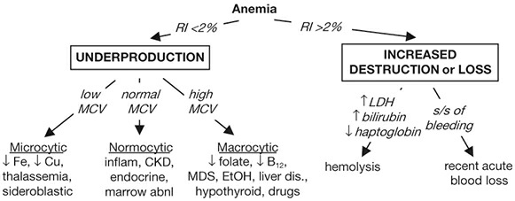  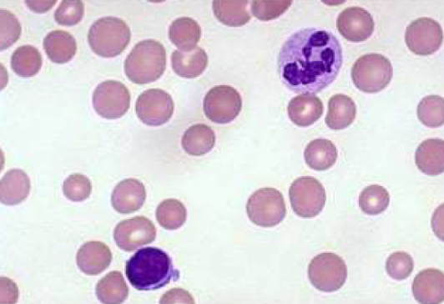 | Ix  - Sparse distributed rbcs, with some rbc macro-ovalocytotic with and few microcytosis, some with pallor some not => variable (anisopoikolocytosis)  - Hyper segmented > 7 nuclear lobules  - DDX: Macrocytic Anemia sec? FA deficiency, B12? infections, Chronic liver disease  - B12 def etiologies: malnutrition (alcoholism, vegan), pernicious anaemia (PA, autoimmune gastritis), ↓ absorption (gastrectomy, sprue, Crohn’s, metformin)  - If B12 (even low nl); ↑ homocysteine & methylmalonic acid; anti-IF Ab; ↑ gastrin in PA  Rx  - 1 mg B12 IM od × 7 d → once/wk × 4–8 wk → once/mo for life  - neurologic abnormalities are reversible if treated w/in 6 mos  - folate 1–5 mg PO od for 1–4 mo or until complete hematologic recovery; critical to r/o B12 deficiency first  - folate can reverse hematologic abnormalities of B12 deficiency but not neurologic changes
Pt asx later had mild constitutional s/s related to splenomegaly. Worsening constitutional sx, bone pain, rapid ↑ in spleen size herald disease progressionCBC results showed….  a. The CBC had Low Hb but High WBC,PLT plus hata monocytes, eosinophils and basophil were kinda elevated. Plus kulikuwa na myelocytes na metamyelocytes.  b. What is your diagnosis  c. ⁠what are your differentials  d. ⁠what are other investigations would you do to confirm your diagnosis  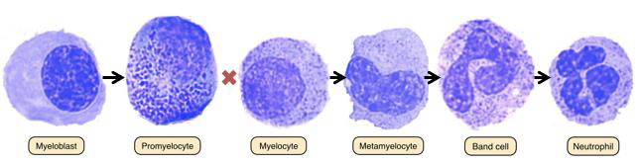  increase N:C ratio - azurophilic granules -kidney shaped - horse shoe - segmented | Ix  - CML usually is myeloproliferative neoplasm with clonal overproduction of hematopoietic myeloid stem cells that can differentiate ( so usually very little blast)  - (Ph) = t(9;22) → BCR-ABL1 fusion → ↑ Abl kinase activity. BCR-ABL1 required for diagnosis (make via karyotyping or FISH; PCR)  - Dx: CML Leukemia, w/ Blast DDx Infection with reactive leukemoid response  Usually Chronic phase (CP): <10% blasts; Accelerated phase (AP): 10–19% blasts, ≥20% basos, plts <100k. while Blastic phase (BP): ≥20% blasts (peripheral or marrow) and/or extramedullary leukemia  - Order: Bone marrow w/ karyotype: hypercellular, ↑myeloid:erythroid ratio.  Rx  - TKI inhibit abl kinase activity 1st gen: imatinib; 2nd gen: nilotinib, old therapy hydroxyurea. Consider allogeneic HSCT for AP and BP.
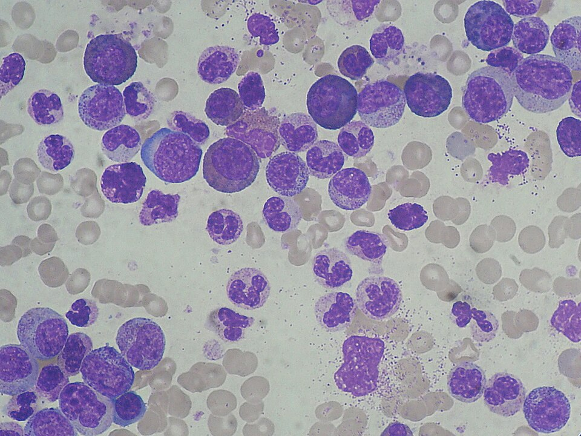  39-year-old patient has WBC 165 × 10^9/L and splenomegaly. Interpret the supplied blood film  - Describe white-cell pattern and maturation spectrum visible in the field.  - Give the most likely diagnosis and the molecular abnormality/test that confirms it.  - Give two features that help distinguish CML from a reactive leukemoid response.  - Name three immediate complications of marked leucocytosis or treatment that you would monitor for. | Ix  - RBC: Polychromasia with some normal pallor other loss of central pallor, there is also great inter RBC distance most are small in size/ but there is difference in shape some elliptical – microcytic anemia  - WBC: has increased neutrophils with mixed spectrum of immature with cells, increased nuclear to cytoplasmic ration loose chromatin: myeloblasts, horse shoe nucleus – metamyelocytes, promyelocyte, bands & smudge cells. many are at stage after promyelocytes so dx CML  - To differentiate the two;  - CML: Myelocyte bulge + basophilia/eosinophilia; BCR: ABL1/Ph+, often splenomegaly and thrombocytosis.  - Leukemoid reaction: Toxic neutrophils/Döhle bodies; BCR: ABL1− with infection/inflammation trigger, no clonal disorder or persistent basophilia.  Other key manifestations  - Cytopenias → fatigue (anemia), infection (neutropenia), bleeding (thrombocytopenia)  - Leukostasis (more in AML): blast >50k, ARDS/PE↓ SaO2, HA, Retinal Artery occlusion, confusion, TIA/CVA  - Tumor lysis syndrome (TLS) from rapid turnover of cells : Hyper K+, AKI, HyperPO3+  - DIC; especially with APL  - Other: leukemic infiltration of skin, gingiva (esp. with monocytic subtypes); chloroma (myeloid sarcoma): extramedullary tumor of leukemic cells, any location; anterior mediastinal mass and SVC syndrome (T-ALL/LBL); hepatosplenomegaly (ALL and monocytic leukemias); leukemic pneumopathy; CNS (~10% of ALL; also in monocytic > myeloid): cranial neuropathies, HA
 | Rx  - IV ceftriaxone 2gm bd 10/7  - IV dexamethasone 10 mg IV q6h × 4 d recommended  prior to or with initiation if bacterial suspected with abx. Greatest benefit in S. pneumoniae. H influenza & Tuberculosis and GCS 8–11 (↓ neuro disability & mortality by ~50%)! if not these stops.  - If high risk >1 risk factor for L. monocytogenes: • Age over 60 years • pregnancy • immunocompromised state. Add ampicillin or amoxicillin IV 2 g (50 mg/kg in children) every 4 hours  - If resistance of S. pneumoniae at the add vancomycin IV 15–20 mg/kg every 8–12 hours  - Monitor for complication: subdural empyema, brain abscess, hydrocephalus, vasculitis stroke, visual field cuts, CN palsies, new-onset seizure disorders, long term sequela: Sensineural hearing loss.
  Parameter | Result | Interpretation
  Appearance | Turbid | Indicates high cellularity (infection/inflammation)
  Xanthochromia | Nil | No evidence of subarachnoid hemorrhage or old bleed
  Total Leukocyte Count (TLC) | 250 cells/mm³ | Markedly elevated → indicates pleocytosis (infection/inflammation)
  Neutrophils | 95% | Predominantly neutrophilic → suggests bacterial meningitis (pyogenic)
  Lymphocytes | 5% | Very low – supports bacterial over viral/fungal/TB etiology
  Proteins | 78 mg/dL | Elevated (>45 mg/dL) → suggests bacterial meningitis, indicates blood-CSF barrier breakdown
  Sugar (CSF Glucose) | 27 mg/dL | Markedly low (normal CSF glucose >60% of blood glucose)
  Blood Sugar (BSR) | 120 mg/dL | CSF/Blood glucose ratio = 27/120 = 22.5% (normal ratio >0.6) → highly suggestive of bacterial meningitis
Immunecompromised Pt with neck stiffness, headache, and blurred vision. Performed CSF with following results…..  CSF appearance -Clear Lymphocytes -85% Protein -1.8g  Csf Glucose - 2.5 Serum Glucose -5.5  Opening pressure -18cm of H2  Interpret the CSF results  - ⁠what is the diagnosis  - ⁠what are your differentials  - ⁠what other tests would you perform for CSF  - d. ⁠how to manage the patient | Ix  - Pt has clear csf w. lymphocytic pleocytosis, elevated protein and low glucose. Likely mycobacteria? TB  - TB meningitis, Fungal menigitis, Cryptococcal, Virals HSV  - To do CSF PCR, ADA, GeneXpert, AFB Stain, Culture  Rx  - 2RHZE/RH 10months. + dexamethasone 0.4mg/kg/day 6hrly or predinisolone 2.5mg/kg/day for 8week tapered from 6 weeks.  - ART within 8weeks
 | Ix  - CNS depression (↓ RR and/or VT): sedatives (opiates, benzos, etc.), CNS trauma, central sleep apnea, obesity, hypoventilation, hypothyroidism  - Neuromuscular disorders (↓ VT): Guillain–Barré, poliomyelitis, ALS, MS, paralytics, myasthenia gravis, muscular dystrophy, severe ↓ P & K, high spinal cord injury  - Chest wall (↓ VT): PTX, hemothorax, flail chest, kyphoscoliosis, ankylosing spondylitis  - Upper airway (↓ VT): foreign body,  - Lower airway (gas exchange) (↑ VD and/or ↓ VT): asthma, COPD, pulm edema, IPF. Often hypoxia → ↑ RR → resp. alk., but muscle fatigue → resp. acid.
  Item | Result | Normal Range | Interpretation
  pH | 7.31 | 7.35–7.45 | Acidemia (low pH)
  pCO₂ | 65 mmHg | 35–45 mmHg | Markedly elevated – indicates respiratory acidosis (primary)
  HCO₃⁻ | 30 mEq/L | 22–26 mEq/L | Elevated – indicates metabolic compensation (renal retention of bicarbonate)
  pO₂ | 47 mmHg | 80–100 mmHg | Severe hypoxemia (respiratory failure)
  O₂ Sat | 76% | >95% | Severe desaturation – indicates significant hypoxemic respiratory failure
A 31 year old female presents with history of fever and jaundice for 7 days, and altered consciousness for 1 day. On exam, she has bruises all over her body. Labs reveal: Bilirubin 14 mg/dl, ALT 3327 IU/ml, AST 2980 IU/ml, Alk Phos 380 IU/ml, PT 50/13 sec, aPTT 78/33 sec.  - What is the diagnosis?  - What further investigations will you order?  - How will you manage? | Ix  - Dx: Acute liver injury (<26 wks) + coagulopathy + encephalopathy w/o preexisting liver disease except autoimmune hepatitis, Budd–Chiari, Wilson disease  - Fulminant if encephalopathy <8 wks from jaundice onset, subfulminant if 8–26 wks  - Also order  - CBC, PT/PTT, LFTs, lytes, BUN/Cr, NH3, pH, arterial lactate, acetaminophen level, HIV, amylase/lipase, viral serologies (qv) in all, with additional labs as below if suspected  - Autoimmune hep serologies & IgG levels, ceruloplasmin & serum/urine copper, preg test  - Imaging studies (RUQ U/S or abd CT, Doppler studies of portal and hepatic veins)  - Liver biopsy if underlying etiology remains elusive after initial testing  Rx  - Encephalopathy: intubate for grade 3 or 4; lactulose is of little benefit & may be detrimental  - Coagulopathy: vit K, FFP/plts/cryo only if active bleeding (↑ risk of volume overload)  - Infection: low threshold for abx (broad spectrum, eg, vancomycin & 3rd-gen ceph.) if suspect infection; antifungal coverage in high-risk Pts (TPN, CVVH)  - Rx of specific causes: NAC if acetaminophen; antiviral for HBV; plasma exchange can be temporizing measure for Wilson disease; IV acyclovir for HSV;
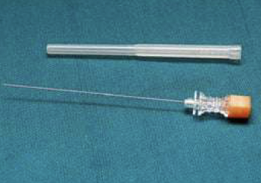  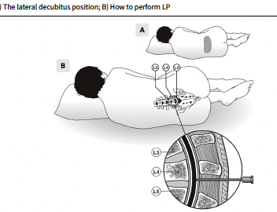
  Absolute contraindications
  LP should not be performed in the presence of any of the following:
  - Ongoing haemodynamic instability (until stabilized)
  - Ongoing respiratory failure (until stabilized)
  - Severe bleeding disorder <15 Platelets
  - Skin or soft tissue infection overlying or close to puncture site and spina bifida lesion in neonates
  - Epidural abscess close to puncture site
  Relative contraindications
  A set of clinical criteria can be used to select at-risk individuals (children and adults) who require cranial imaging before LP to rule out the presence of cerebral space-occupying lesions with midline shift, obstructive hydrocephalus or severe cerebral oedema:
  - GCS <10
  - Focal neurological signs
  - Cranial nerve deficits
  - Papilloedema
  - New-onset seizures (in adults)
  - Severe immunocompromised state
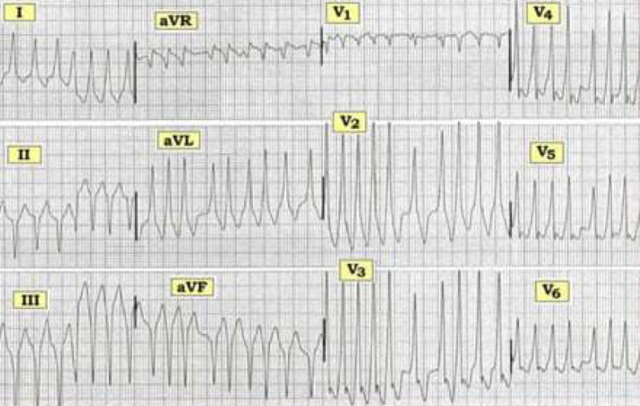 | Ix:  - Etiologies: ischemia; CMP; catecholaminergic (CPVT) torsades de pointes (TdP = “twisting of the points,” PMVT + ↑ QT): ↑ QT acquired (meds, lytes, stroke, see “ECG”) w/ risk ↑ w/ ↓ HR, freq PVCs (pause dependent) or congenital (K/Na channelopathies like Brugada syndrome)  - Workup: echo to ✓ LV fxn, angio or stress test to r/o ischemia, ? MRI and/or RV bx to look for infiltrative CMP or ACM, ? to assess VT in Pts w/o ICD indication  Rx  - If pulseless, CPR then immediate shock.  - ICD: 2° prevention for VT/VF arrest (unless due to reversible cause) or cardiac syncope  - Meds: βB, antiarrhythmics (eg, amio, sotalol, mexiletine, quinidine); verapamil if fascicular VTa
Pt with AMS, weight loss, hyperpigmentation(nausea and vomiting?) and salt craving.Urine dipstick negative for protein, red blood cells, …  - Na=126 , K= 6.8 , bicarbonate =….. plus BUN and Creatinine  - What is your diagnosis  - ⁠what diagnostic investigations would you perfom  - d. ⁠what is the definitive management | Ix  - ACTH stimulation test (testing ability of 250 μg ACTH → ↑ cortisol) normal = 60-min (or 30-min) post-ACTH cortisol ≥15 μg/dL  - Can use early a.m. cortisol instead before 9am  - Without stimulation, early a.m. serum cortisol: <3 μg/dL virtually diagnostic ≥15 excludes chronic AI  - Other tests: renin, aldosterone, insulin-induced hypoglycemia, plasma 11-deoxycortisol and urinary 17-hydroxycorticosteroid levels), hypoglycemia, eosinophilia, lymphocytosis, ± neutropenia  - ACTH: ↑ in 1°, ↓ or low-normal in 2°  - pituitary MRI, adrenal CT: small, noncalcified adrenals in autoimmune, enlarged in metastatic disease, hemorrhage, infection or deposition  Rx  - Acute insufficiency: hydrocortisone 100 mg IV followed by 50 mg IV q6 + IVFw/ normal saline  - Chronic insufficiency: (1) prednisone ~4–5 mg PO am or hydrocort 15–25 mg PO od (2/3 a.m.,1/3 early p.m.)
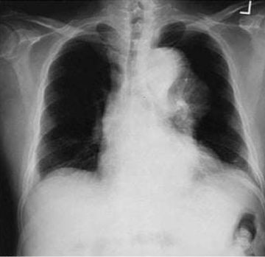  A 60-year-old male presented at the Emergency Room with severe chest pain of sudden onset. This was his CXR.  - What is the diagnosis? | Ix  - CXR: abnl in 60–90% [wide↑ mediast, L pl effusion] but cannot r/o AoD.  - CT aortogram: preferred as quick & available; see entry point, extent, & complications; Se & Sp ≥93%  - Type A = proximal: involves ascending Ao, regardless of origin  - Type B = distal: involves descending Ao only, distal to L subclavian artery  - TEE: + assess (sx, BP, UOP), pulses, labs (Cr, Hb, lactic acid), imaging (~7 d or sooner if Δs)  Rx  - First IV βB (eg, esmolol, labetalol) to blunt reflex ↑ HR & inotropy response to vasodilators  - Type A: surg consult in all acute (<15 d) and in chronic if c/b progression, AI or aneurysm  - Type B: med Rx unless complic. (below) or high risk of adverse remodeling  - Complications:  - Progression: propagation of dissection, ↑ aneurysm/false lumen size  - Rupture: pericardial sac → tamponade  - Malperfusion (partial or complete obstruction of branch artery; can be static or dynamic)  - coronary → MI (usually RCA → IMI b/c dissection follows outer Ao curvature);  - innominate/carotid→ CVA, Horner;  - intercostal/lumbar → cord ischemia/paraplegia  - celiac/mesenteric → bowel ischemia  - renal → AKI or slow ↑ Cr, refractory HTN
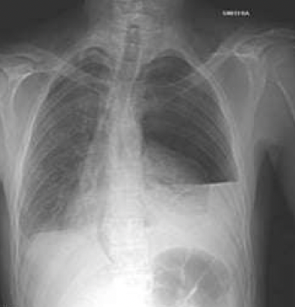  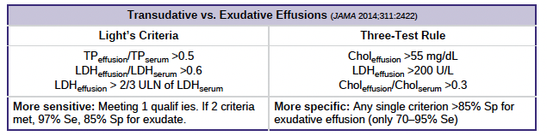 | Ix  - A well-defined horizontal air-fluid level in the left hemithorax, creating an appearance that resembles a hydropneumothorax or a loculated fluid collection with an air component  - Also: Thoracentesis (ideally U/S guided), all effusions >1 cm in decubitus view.  - Procedure complications: PTX (5–10%), hemothorax (~1%), reexpansion pulm edema (if >1.5 L removed), spleen/liver laceration, nerve injury – long thoracic nerve, bronchopleural fistula  - ADA: seen w/ granulomas, >70 suggests TB, <40 excludes TB. Cytology - +ve malignancy  - Consider pleural biopsy for unresolving effusion with no clear cause  Rx  - Symptomatic effusion: therapeutic thoracentesis, treat underlying disease process  - loculated→ tube thoracostomy or VATS; intrapleural tPA + DNase ↓ need for surgery  - Indication for pleurodesis:  - Malignant effusion: serial thoracenteses vs. tube thoracostomy + pleurodesis (success rate ~80: use bleomyocin, doxycycline, iodine, or surgical stripping  - Recurrent CHF, chylothorax, hydrothorax if fails
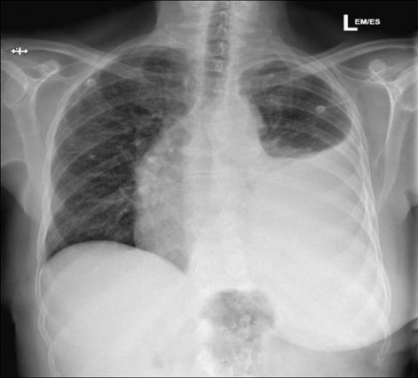 | Ix  - Homogeneous opacity with meniscus sign over middle and lower lt lung zone with mediastinal shift to the rt. The cardiac silhoute is pushed to rt with trachea deviation  - Dx: Parapneumonic Effusion ddx: pleural TB, mesothelioma, primary lung ca w/ pleural mets?, autoimmune i.e SLE
A 23 year old male, known asthmatic for 4 years presents with worsening shortness of breath for 6 hours. On exam, he has Pulse of 140/min, RR of 40/min, and BP 90/60mmHg.  - He is cyanosed. Chest is bilateral silent.  - How will you manage this patient? | Ix  - Also, Spirometry: ↓ FEV1, ↓ FEV1/FVC; volumes; TLC  - ⊕ bronchodilator response (↑ FEV1 ≥12% & ≥200 mL) for 4hrs free from SABA, 24-48hrs if on LABA  - methacholine challenge (↓ FEV1 ≥20%) if PFTs nl:  - If suspicion for atopic disease, ✓ skin prick test, serum IgE, blood/sputum eos, fractional exhaled  - FENO; ≥40 parts/bil suggest T2 inflammation  - DDx: Eosinophilic granulomatosis w/ polyangiitis, ABPA, COPD; bronchiectasis; ILD (including sarcoidosis); vasculitis; PE  Rx  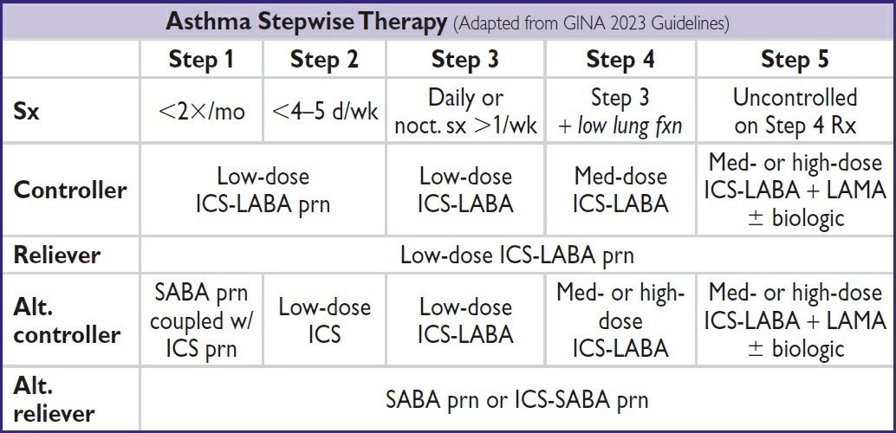  - Anti-IL-4Rα (dupilumab) blocks IL-4 & IL-13; ↓ exacerb in sev. asthma, ↓ steroid use, ↑ FEV1  - Anti-IgE (omalizumab) uncontrolled severe allergic asthma (w/ IgE >30) on ICS ± LABA
The question was about a pt. with bronchial asthma who came with wheezing on examination she had a respiratory rate of 34, oxygen saturation was 89 and use of accessory muscle for breathing  - What is the likely diagnosis?  - Features on examination that will tell that the pt. is in distress  - c. How will u manage. Drugs and doses and means of administration | Rx  - Oxygen to keep SaO2 ≥92-95%  - Inhaled SABA salbutamol) by MDI (4–8 puffs) or nebulizer (5 mg) q20min + Ipratropium + Budesonide MDI (4–6 puffs) or nebulizer (0.5 mg) q20min to 6hrly  - Corticosteroids: prednisone 40–60 mg PO × 5–7 d  - Non-invasive ventilation: improves obstruction & ↓ odds of mechanical ventilation and mortality + Mg 2gm stat  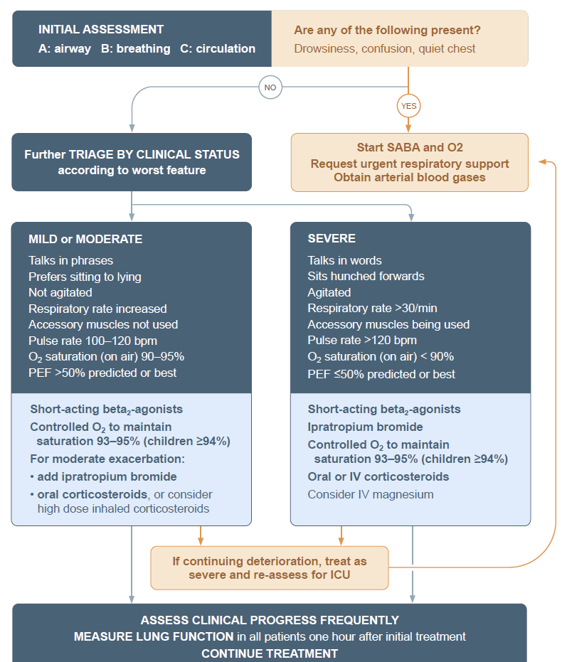
Pt with shortness of breath given inhaled corticosteroid. Spirometery done before and after brochodilators, results were….  - Table ya result ilikuwa inaonesha FEV1 before broncodilators and after plus ilikuwa na predicted value  - Calculate the change in FEV1  - ⁠interpret the results  - ⁠what is your diagnosis  - e. ATS/ERS criteria | Ix  - PFTs: obstruction: ↓ FEV1, ↓ FVC, FEV1/FVC <0.7 (no sig Δ post bronchodilator), expiratory coving of flow-volume loop; hyperinflation: ↑↑ RV, ↑ TLC, ↑ RV/TLC; abnormal gas exchange: ↓ DLCO (in emphysema)  - ABG: ↓ PaO2, ± ↑ PaCO2 (in chronic bronchitis, usually only if FEV1 <1.5 L) and ↓ pH  Rx  - 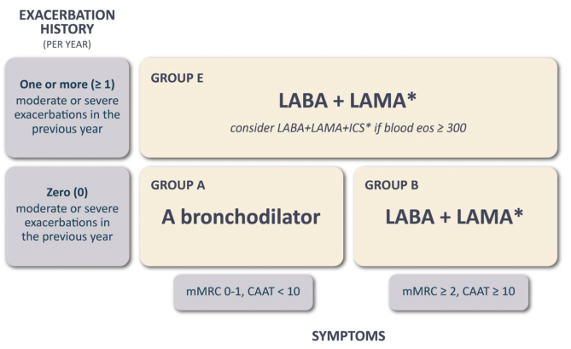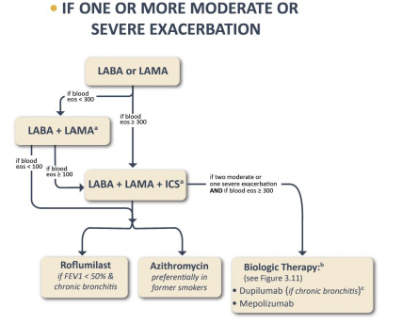  - Dupilumab (anti-IL-4, IL-13): ↓ exacerb, ↑ FEV1 if Pts w/ eos >300  - long-term administration of oxygen (> 15 hours per day; LTOT) if: PaO2 at or below 55 mmHg (7.3 kPa) or SaO2 at or below 88%, with or without hypercapnia confirmed twice over a three-week period; or PaO2 55 mmHg (7.3 kPa) and 60 mmHg (8.0 kPa), or SaO2 of 88%, if has of pulmonary HTN, edema CHF, or polycythemia (hematocrit > 55%)  - Also: Flu/Pneumovax; smoking cessation, Rehabilitation: ↓ dyspnea and fatigue, ↑ exercise tolerance, ↑ QoL
A 28 year old female has recently been diagnosed with HIV while screening at the time of delivery of her first baby. She is worried and apprehensive about the disease. How will you counsel her?  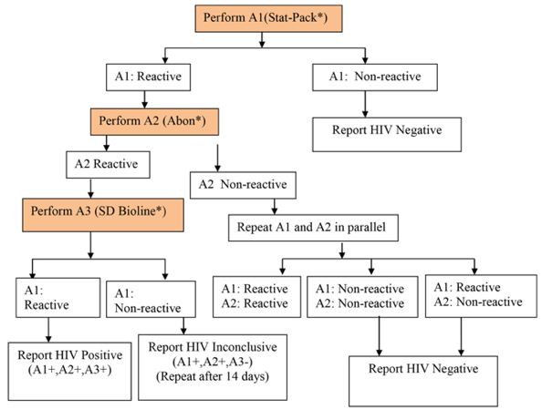 | Rx  - Counsel re: excellent prognosis w/ adherence to treatment, treatment options, & disclosure  - Lab eval: CD4, HIV VL & genotype, CBC w/ diff., BMP, LFTs, HbA1c, lipids, UA, PPD/ IGRA, syphilis, Chlam. & gonorrhea (3 site), Hep A/B/C, anal PAP if MSM or transgender ♀ >35, hCG,  - If AIDS: CMV IgG, Toxo IgG, G6PD.  - Confirm all vaccinations (including annual flu) are up to date, avoid live vax if CD4 ≤200  - Initiate ARV early (same day, preferably after labs/genotype regardless of CD4 level because ↓ mortality  - Rx prevents transmission to partners. Risk of transmission w/ unprotected sex is ~0% (untransmissible) if VL undetectable >6 mo
54y/o presents with abdominal distension and yellowish discoloration of the eyes. Reports to heavily drink Konyagi  - What is your diagnosis  - ⁠what are your expected signs you will see on abdominal examination  - ⁠what is your differential diagnosis  - d. ⁠what other investigations would you perform | ?????
Diabetic pt not on antigylemics, has cough with green sputum for 6 days; presents to EMD with confusion. RBG is high, has hypotension has sweet breath on examination  - What is the diagnosis for the 6 days presentation?  - what other 4 tests other than RBG  - mention 2 likely causes of confusion in this patient  - how to manage the patient | A 14 year school girl presents in emergency with 03 days severe abdominal pain and vomiting. On examination she is drowsy, severely dehydrated and has labored breathing. She has a BP of 90/60mm Hg and her temp is 100°F. Her blood sugar is 600mg/dl.  - What is the diagnosis?  - How will you investigate?  - How will you manage?
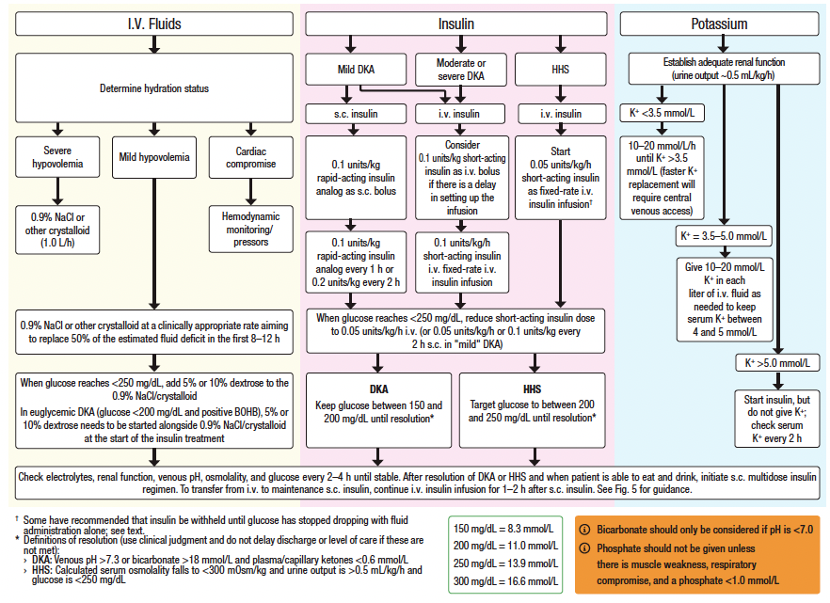
A man came complain of facial swelling that progressed to the lower limb. He passes frothy urine  - What is the mostly likely dx?  - What other findings will u see  - How will manage the pt. (drug, dose, duration + mean of administration)  - What are the complications  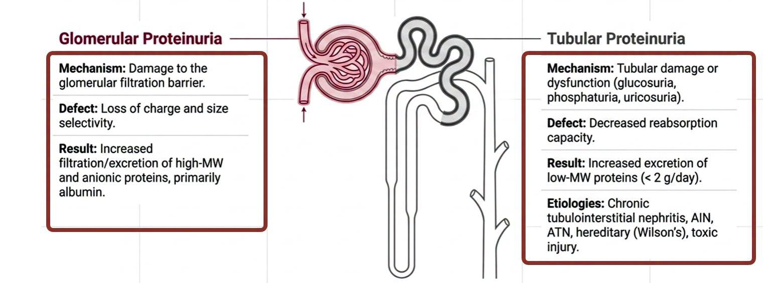  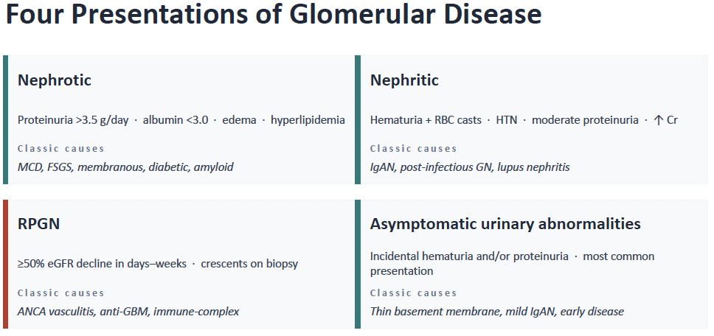  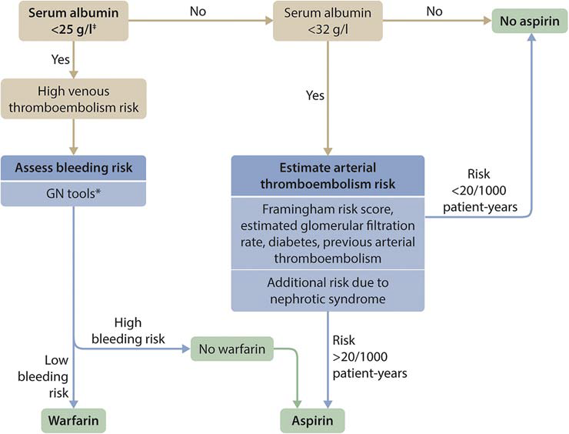 | Ix  - Nephrotic: Podocyte injury (effacement) → loss of proteins (albumin, ATIII, Ig). Clinically: proteinuria >3.5 g/d, albumin <3 g/dL, edema, ↑ chol., VTE (25%), infection  - U/A + sediment: usually benign; ± oval fat bodies (Maltese)  - Measure proteinuria: 24-h urine or spot urine protein/Cr ratio (not accurate in AKI) >3.5 g/24 hr (or UPCR >3.5)  - Renal bx if  - nephrotic syndrome refractory to steroid  - Adult-onset nephrotic syndrome  - Hematuria + proteinuria >0.5 g/day  - Unexplained AKI without obvious cause  - Any RPGN  - Serologic workup inconclusive  - Test for 2° causes: ↑ HbA1C + retinop. → DM; ✓ ANA, anti-dsDNA, tox screen, C3/C4, SPEP/light chains, cryocrit, HBV/HCV, HIV, RPR, APLA2R Ab, age-approp. CA screen  Rx  - Protein suppl.; diuretics for edema; treat hyperlipidaemia with atorvastatin 20-40mg od , Na restriction (<2 g/d)  - ACEI/ARB: Lisinopril 5mg of ↓ proteinuria → slow nonimmunologic progression of renal disease  - 1° glomerular: steroids: prednisolone1mg/kg/d max 80mg/d ± rituximab or cytotoxic: cyclophosphamide as 2° line  - Secondary causes: treat underlying disease  - Watch for malnutrition (protein loss), consider anticoag if albumin <2.5 since protein c/s which are anticoagulant are lost  - Rx infection (esp. encapsulated organisms b/c loss of immunoglobulins) also vaccinate
  A woman came a complain unexplained weight loss, irritability, heat intolerance,  - What is the most likely diagnosis?  - What other findings will u see on physical examination  - What investigations will u do  - What is the most feared complication?  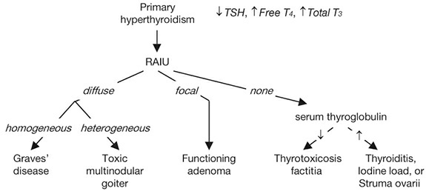 | Ix  - Periorbital edema, lid retraction, proptosis, conjunctivitis, diplopia (EOM infiltration); associated w/ smoking. Stare and lid lag seen in any type of hyperthyroidism  - Dx: Graves Ophthalmopathy  - Other findings: Restlessness, tremor, moist, warm skin, fine hair, ↑ HR, wide pulse pressure, AF, weight loss, ↑ frequency of stools, menstrual irregularities, hyperreflexia, osteoporosis, stare, and lid lag (2/2 sympathetic overactivity), Pretibial myxedema (3%): infiltrative dermopathy, Goiter: diffuse, nontender, w/ thyroid bruit  - Tests: ⊕ thyroid antibodies: TSI or TBII (⊕ in 80%), anti-TPO, antithyroglobulin; ANA;  - Ddx: Thyroiditis: thyrotoxic phase of subacute (granulomatous) or painless (lymphocytic, Toxic adenomas (single or multinodular goiter), Extremely rare: TSH-secreting pituitary tumour  Rx  - β-blockers: control tachycardia (propranolol 40mg to 160mg/d in 1-4 divided doses; also ↓ T4 → T3 conversion)  - Graves’ disease: either antithyroid drugs or radio-iodine  - Carbimazole (10-30mg bd): 60% chance of recurrence after 1 y; side effects include pruritus, rash, arthralgia, fever, N/V, and agranulocytosis in 0.5%.  - PTU: 2nd line (risk of hepatocellular necrosis; TID dosing; slower effect, check LFT, WBC, TSH at baseline & followup  - Radioactive iodine but first do preRx w/ antithyroid drugs.  - Surgery: less commonly chosen for Graves’, usually for Pts w/ obstructive goiter or ophthalmopathy. Adverse effects hypoparathyroidism, recurrent laryngeal nerve injury.
Given a CBC of a pt. which had low HB, low WBC, low PLT, normal MCV AND MCH  - What is the diagnosis  - Describe the finding from the cob  - What other investigation will u do | Ix  - Marrow infiltration/replacement: malignancy, infection (TB, fungal), storage disorder  - Marrow aplasia/failure: aplastic anemia, PNH, large granular lymphocytic leukemia, HLH, nutrition, alcohol, viral  - Destruction/consumption/redistribution: DIC, splenomegaly  - Likely Aplastic anemia if pancytopenia w/ ↓ retics, BM bx w/ hypocellularity, usually nl cytogenetics.  - Etiologies: idiopathic ( ½–⅔ of cases), Stem cell destruction: radiation, chemotherapy, chemicals (eg, benzene), Med rxn (eg, chloramphenicol, NSAIDs, sulfa drugs, gold, carbamazepine, antithyroid). Viruses (HHV-6, HIV, EBV, parvovirus B19); post-viral hepatic failure (not Hep A/B/C); Immune disorders (SLE, GVHD post-HSCT, thymoma  - Do Abs ret =RBC X Reticulocyte Cnt % X 10,000; If absolute ret >60k then its normal reactive. Then the cause of anemia is something else.  Rx  - Rx & prognosis depend on severity & age. Supportive care w/ transfusions & infxn ppx, consider HSCT, “triple immunosup. therapy” (IST, anti-thymocyte globulin, cyclosporine, eltrombopag)

